Muhammad Sameer I.D # FA18-BECE-0014

11 Lab 11 – Introduction to LAB VIEW

TASK 01

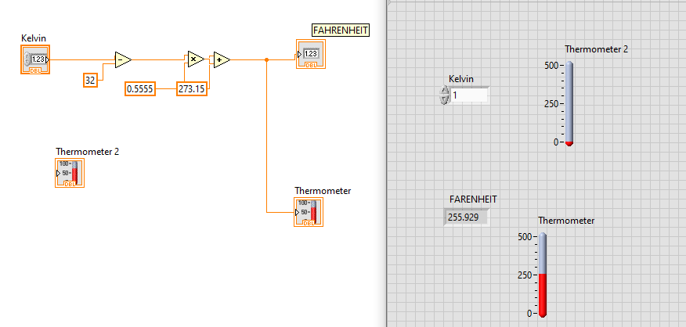

TASK 02

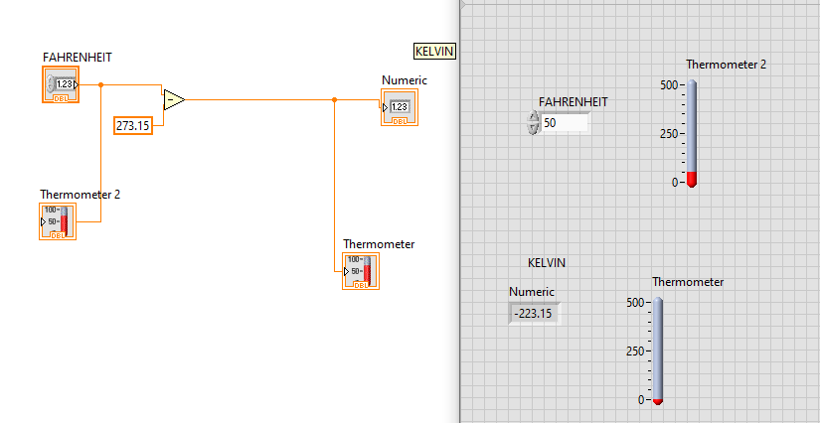

TASK 03

